UNIT 3
ROLES OF GRID COMPUTING AND AUTONOMIC COMPUTING IN CLOUD COMPUTING

3.1. Introduction to Grid Computing:
- Grid Computing can be defined as a network of computers working together to perform a task that would rather be difficult for a single machine.
- All machines on that network work under the same protocol to act like a virtual supercomputer.
- The task that they work on may include analysing huge datasets or simulating situations which require high computing power.
- Computers on the network contribute resources like processing power and storage capacity to the network.
- Grid Computing acts like a supercomputer by connecting many computers and resources across globe.
- These computer resources are heterogeneous and geographically dispersed.
- Grid Computing breaks complex task into smaller pieces, which are distributed to CPUs that reside within the grid.
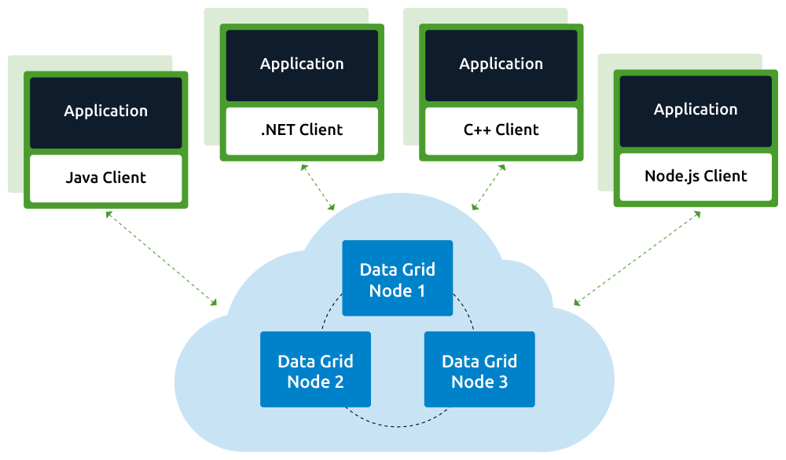

- The meaning of the term Grid Computing has changed over the years, according to “The Grid: Blueprint for a new computing infrastructure” by Ian Foster and Carl Kesselman published in 1999, the idea was to consume computing power like electricity is consumed from a power grid.
- This idea is similar to current concept of cloud computing, whereas now grid computing is viewed as a distributed collaborative network.
- Currently grid computing is being used in various institutions to solve a lot of mathematical, analytical and physics problems.
Working:
A Grid computing network mainly consists of these three types of machines
Control Node:
- A computer, usually a server or a group of servers which administrates the whole network and keeps the account of the resources in the network pool.
Provider:
- The computer which contributes it’s resources in the network resource pool.
User:
- The computer that uses the resources on the network.
Full Mechanism of Grid Computing
- When a computer makes a request for resources to the control node, control node gives the user access to the resources available on the network. When it is not in use it should ideally contribute it’s resources to the network. Hence a normal computer on the node can swing in between being a user or a provider based on it’s needs. The nodes may consist of machines with similar platforms using same OS called homogeneous networks, else machines with different platforms running on various different OS called heterogeneous networks. This is the distinguishing part of grid computing from other distributed computing architectures.
- For controlling the network and it’s resourcing a software/networking protocol is used generally known as Middleware. This is responsible for administrating the network and the control nodes are merely it’s executors. As a grid computing system should use only unused resources of a computer, it is the job of the control node that any provider is not overloaded with tasks.
- Another job of the middleware is to authorize any process that is being executed on the network. In a grid computing system, a provider gives permission to the user to run anything on it’s computer, hence it is a huge security threat for the network. Hence a middleware should ensure that there is no unwanted task being executed on the network.
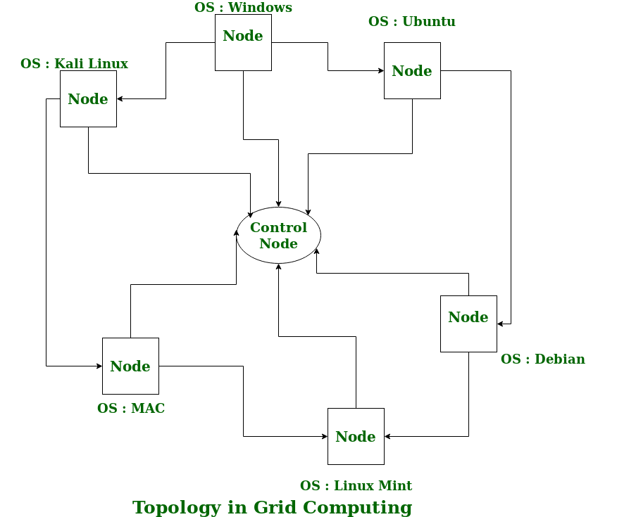
Advantages of Grid Computing:
- Easier to collaborate with other organizations.
- Make better use of existing hardware.
- No need to but huge servers for applications that can be split up and farmed out to smaller commodity type servers.
- Grid environments are much more modular and don’t have single points of failure. If one of the servers/desktops within the grid fail there are plenty of other resources able to pick the load.
- Jobs can be executed in parallel speeding performance
- Can solve larger, more complex problems in a shorter time.

Disadvantages of Grid Computing:
- Grid software and standards are still evolving.
- Learning curve to get started.
- Non-interactive job submission.
- You may need to have a fast interconnect between compute resources.
- Licensing across many servers may make it prohibitive for some applications.
- Many groups are reluctant with sharing resources even if it benefits everyone involved.

3.2. Distributed Computing in Grid and Cloud:
Distributed Computing:
- In distributed computing we have multiple autonomous computers which seems to the user as single system.
- In distributed systems there is no shared memory and computers communicate with each other through message passing.
- In distributed computing a single task is divided among different computers.
- A computer in the distributed system is a node while a collection of nodes is a cluster.
- They work together to achieve the common goal.
- Grid is based on grid computing whereas cloud does not support Distributed computing as they have no mainly the automatic and instant scalability of resources.
- Distributed computing concept evolved in 1995

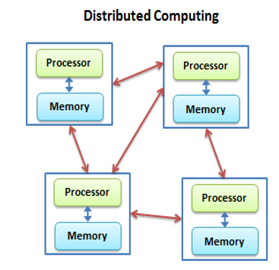

Advantages
- It allows scalability and makes it easier to share resources easily.
- It also helps to perform computation tasks efficiently.
Disadvantages:
- On the other hand, it is difficult to develop distributed systems.
- Moreover, there can be network issues.

3.3. Interoperability in Grids and Clouds:
- Cloud interoperability refers to the ability of the systems to work efficiently and collaborate effectively across different cloud platforms. It is emerging as an essential element in Cloud strategy as companies seek to mitigate vendor lock-ins, ensure business continuity and navigate through fluctuating workloads. At its core, interoperability requires shared processes, APIs, containers and data models across the multi-cloud environment to enable communication between application components. It also requires dynamic discovery of application components, along with real time data synchronization. These requirements centered around data and application component synchronization across different cloud platforms make interoperability a challenging proposition.
- Cloud interoperability requires shared processes, APIs, containers and data models across the multi-cloud environment to enable communication between application components.
- The grid and cloud both share the same vision of providing services
- Both are based on network technology and are capable of multitasking
- In grid computing, resources are distributed over grids, whereas in cloud computing, resources are managed centrally.
Challenges of Interoperability of Cloud Computing
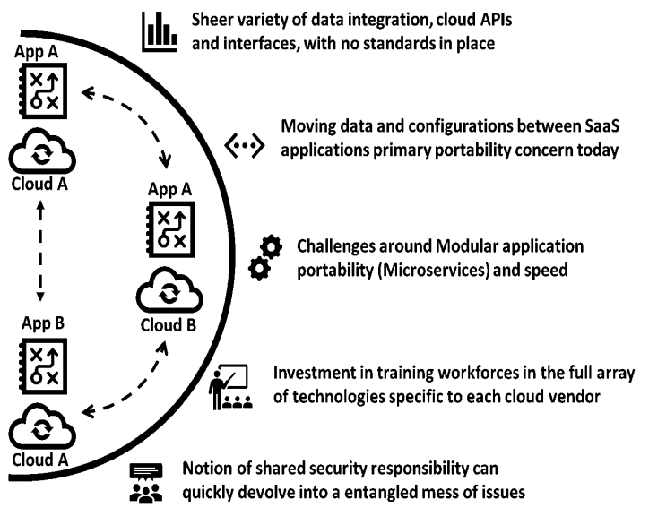

3.4. Autonomic Computing:
- Autonomic Computing is a type of visionary computing that has been started by IBM.
- This is made to make adaptive decisions that use high-level policies. It has a feature of constant up-gradation using optimization and adaptation.
- Learns automatically from learning the behaviour or activities of computer
- to resolve system difficulties and other maintenance such as software updates.
- Cut down the effort and time of developers and IT care takers.

History
- It was proposed by Jiming Liu in the year 2001.
- It uses artificial systems to solve complex problems using imitations like that of humans.
- On October 15 of the year 2001, IBM Research President, Paul Horn addressed an annual meeting.
- He presented a solution to growing complexities and mentioned that the answer lied in building computer systems that could regulate themselves in a manner in which our nervous systems regulate and protect our bodies.
- E.g. Ant-colony optimization nt colony optimization is a metaheuristic that we based on population for finding approximate solutions to complex optimization problems.

Need Of Autonomic Computing:
- With the increase in the demand for computers, computer-related problems are also increasing. They are becoming more and more complex. The complexity has become so much that there is a spike in demand for skilled workers. This has fostered the need for autonomic computers that would do computing operations without the need for manual intervention.
Areas Of Autonomic Computing:
There are four areas of Autonomic Computing as defined by IBM. These are as follows:

Self-Configuration: The system must be able to configure itself automatically according to the changes in its environment.
Self-Healing: IBM mentions that an autonomic system must have property by which it must be able to repair itself from errors and also route the functions away from trouble whenever they are encountered.
Self-Optimization: According to IBM an autonomic system must be able to perform in an optimized manner and ensure that it follows an efficient algorithm for all computing operations.
Self-Protection: the IBM States that an autonomic system must be able to perform detection, identification, and protection from the security and system attacks so that systems’ security and integrity remain intact.
Characteristics
- The Autonomic system knows itself. This means that it knows its components, specifications capacity, and the real-time status. It also has knowledge about its own, borrowed, and shared resources.
- It can configure itself again and again and run its setup automatically as and when required.
- It has the capability of optimizing itself by fine-tuning workflows.
- It can heal itself. This is a way of mentioning that it can recover from failures.
- It can protect itself by detecting and identifying various attacks on it.
- It can open itself. This means that it must not be a proprietary solution and must implement open standards.
- It can hide. This means that it has the ability to allow resource optimization, by hiding its complexity.
- An autonomic system according to IBM must be able to know or expect what kind of demand is going to arise for its resources to make it a transparent process for the users to see this information.
Autonomic Computing (AC) Architecture
- The autonomic computing is needed so that it overcomes the problem of the increased complexity of the computing systems that acts to prevent further growth of the systems. There are several predictions with suggesting growth of 38% devices per annum with increased complexity.
- There is a need for autonomic computing in distributed computing because of the management of the computer networks complexes and a limiting factor in the future development of distributes computing systems.
- Mobile computing has brought with it an increased complexity for employee management systems as employees need to access their company’s data even when they are not in the office.
- All such cases of complexity arise a need for autonomic computing as it’s better than manual computing that is erroneous and time-consuming. Autonomic computing is a system that deploys high-level policies to make decisions.
- It is based on the architecture that is called MAPE that stands for monitor, analyze plan, and execution. The architecture revolves around the idea of a reduction in management costs.
- The AC architecture comprises attributes that allow self-management, according to various vendors by involving control loops.

Control loops: A resource provider provides control loops. It is embedded in the runtime environment.
It is configured using a manageability interface that is provided for every resource e.g. hard drive.
Managed Elements: The managed element is a component of the controlled system. It can be hardware as well as a software resource. Sensors and effectors are used to control the managed element.
Sensors: This contains information about the state and any changes in the state of elements of the autonomic system.
Effectors: These are commands or (API) that are used to change the states of an element.

Autonomic Manager: This is used to make sure that the control loops are implemented. This divides the loop into 4 parts for its functioning. These parts are monitor, analyze, plan, and execute.
The Autonomic Computing must involve the following 3 properties :
Automatic: It must be able to execute its operations without human intervention.

Adaptive: Autonomic computers must be able to make changes according to their environment and other unforeseen conditions such as security attacks and system breakdowns.

Aware: it must also have awareness of the processes and internal states that would allow the previous two features to be executed.

Advantages
- It is an open-source.
- It is an evolutionary technology that adapts itself to new changes.
- It is optimized hence gives better efficiency and performance thereby taking lesser time in execution.
- It is very secure and can counter system and security attacks automatically.
- It has backup mechanisms that allow recovery from system failures and crashes.
- It reduces the cost of owning (Total Cost of Ownership) such a mechanism as it is less prone to failure and can maintain itself.
- It can set up itself thereby reducing the time taken in manual setup.

Disadvantages
- There will always be a possibility of the system crashing or malfunctioning.
- This would result in an increase in unemployment due to the lesser needs of people after it is implemented.
- The affordability would be an issue because it would be expensive.
- It would need people who are very skilled to manage or develop such systems, thereby increasing the cost to the company that employs them.
- It is dependent on internet speed. Its performance decreases with a decrease in internet speed.
- It would not be available in rural areas where there are lesser provisions of stable internet connection.

